Схема ФНЧ 2 порядка, аппроксимация Баттерворта

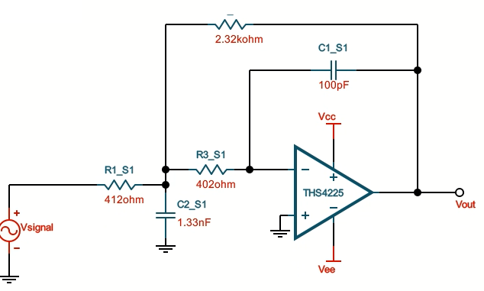

|  |  |
| --- | --- |
| Резистор R1_S1, 412 Ом | Bourns, CR1206-FX-4120ELF |
| Резистор R2_S1, 2.32 КОм | Bourns, [CR0805-FX-2321ELF](https://ru.mouser.com/ProductDetail/Bourns/CR0805-FX-2321ELF?qs=sGAEpiMZZMtG0KNrPCHnjfC2zYK6Lg3%2F%2FiDy1Cnnh28%3D) |
| Резистор R3_S1, 402 Ом | Bourns, [CR0805-FX-4020ELF](https://ru.mouser.com/ProductDetail/Bourns/CR0805-FX-4020ELF?qs=sGAEpiMZZMtG0KNrPCHnjfC2zYK6Lg3%2FSkSpjkK3uZ4%3D) |
| Конденсатор C1_S1, 100 пФ | AVX, 06035A101GAT2A |
| Конденсатор C1_S2, 1300 пФ | Murata Electronics, [GCM2195G2A132GA16J](https://ru.mouser.com/ProductDetail/Murata-Electronics/GCM2195G2A132GA16J?qs=QzBtWTOodeXF7oVJvUlCZw%3D%3D) |
| Операционный усилитель | TI, THS4225 |

Схема ФНЧ 4 порядка, аппроксимация Баттерворта

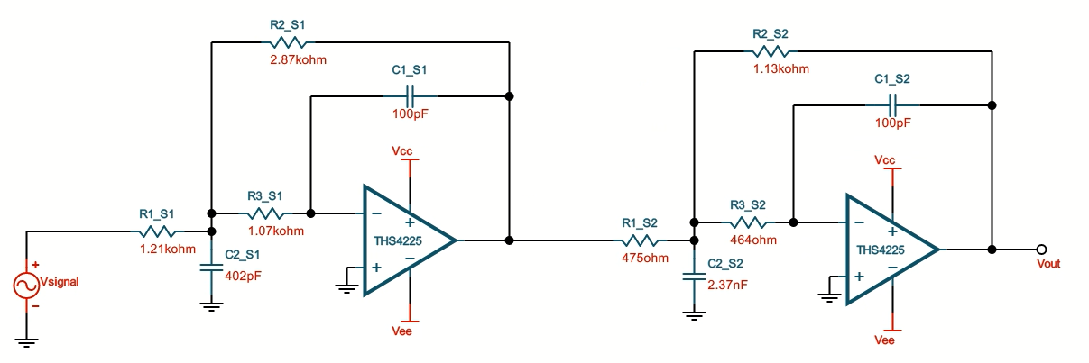

|  |  |
| --- | --- |
| Резистор R1_S1, 1.21 КОм | Bourns, [CR1206-FX-1211ELF](https://ru.mouser.com/ProductDetail/Bourns/CR1206-FX-1211ELF?qs=sGAEpiMZZMtG0KNrPCHnjfC2zYK6Lg3%2FqUITScRtnyE%3D) |
| Резистор R2_S1, 2.87 КОм | Bourns, [CR0402-FX-2871GLF](https://ru.mouser.com/ProductDetail/Bourns/CR0402-FX-2871GLF?qs=sGAEpiMZZMtG0KNrPCHnjfC2zYK6Lg3%2FL8xLJbViLuc%3D) |
| Резистор R3_S1, 1.07 КОм | Bourns, [CR1206-FX-1071ELF](https://ru.mouser.com/ProductDetail/Bourns/CR1206-FX-1071ELF?qs=sGAEpiMZZMtG0KNrPCHnjfC2zYK6Lg3%2FcWAdbQhB1Oc%3D) |
| Резистор R1_S2, 475 Ом | Bourns, CR1206-FX-4750ELF |
| Резистор R2_S2, 1.13 КОм | Bourns, [CR1206-FX-1131ELF](https://ru.mouser.com/ProductDetail/Bourns/CR1206-FX-1131ELF?qs=sGAEpiMZZMtG0KNrPCHnjfC2zYK6Lg3%2FXRaAC2NzOlU%3D) |
| Резистор R3_S2, 464 Ом | Bourns, CR1206-FX-4640ELF |
| Конденсатор C1_S1, 100 пФ | AVX, 06035A101GAT2A |
| Конденсатор C2_S1, 430 пФ | Murata Electronics, [GCM1555C1H431GA16D](https://ru.mouser.com/ProductDetail/Murata-Electronics/GCM1555C1H431GA16D?qs=QzBtWTOodeUhKv0d4N16pA%3D%3D) |
| Конденсатор C1_S2, 100 пФ | AVX, 06035A101GAT2A |
| Конденсатор C2_S2, 2400 пФ | Murata Electronics, [GCM1885G1H242GA16J](https://ru.mouser.com/ProductDetail/Murata-Electronics/GCM1885G1H242GA16J?qs=QzBtWTOodeVWc%2FSN84Uo5g%3D%3D) |
| Операционный усилитель | TI, THS4225 |